**ACTIVITY 8.2:** **SQL Joins**

**Objectives:**

1. To know the difference between **SQL-DDL DROP and TRUNCATE**
2. To know more about SQL commands under DML such as **Insert, Update, Delete and Select.**

**Materials:**

PC or Laptop

WAMP/XAMPP Installer

Web Browser or CLI

1. **DROP**

My command prompt:

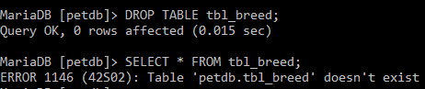

1. **TRUNCATE**

My command prompt:

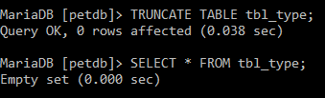

1. **INSERT**

My command prompt:

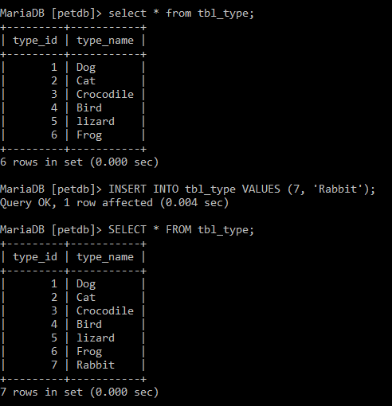

1. **UPDATE**

My command prompt:

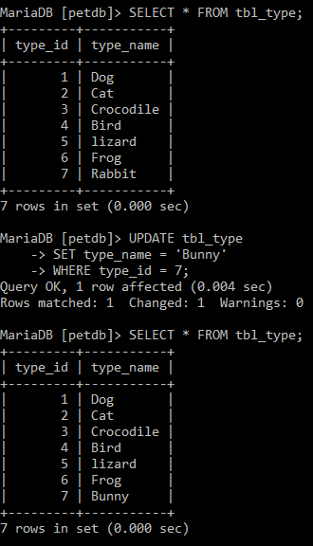

1. **DELETE**

My command prompt:

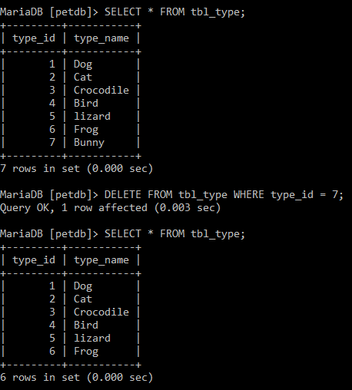

1. **SELECT**

My command prompt:

